GROUP ASSIGNMENT

#TASK 1.
# (a) Input employee details
payrollnumber = input("Enter payroll number: ")
name = input("Enter name: ")
gender = input("Enter gender: ")
jobgroup = input("Enter job group (j, k, l, m): ").lower()
basicsalary = float(input("Enter basic salary: "))

# Allowances dictionary
allowances_dict = {
'j': 5000,
'k': 5500,
'l': 6000,
'm': 6500,
}

# Validate job group
if jobgroup not in allowances_dict:
print("Invalid job group! Please enter j, k, l, or m.")
exit()

# Get allowance amount based on job group
allowance = allowances_dict[jobgroup]

# (b) Computing
grosspay = basicsalary + allowance
taxes = 0.12 * basicsalary # 12% tax
netpay = grosspay - taxes

# (c) Display
print("\n" + "="*40)
print("EMPLOYEE PAYROLL DETAILS")
print("="*40)
print(f"Payroll Number: {payrollnumber}")
print(f"Name: {name}")
print(f"Gender: {gender}")
print(f"Job Group: {jobgroup.upper()}")
print(f"Basic Salary: Ksh {basicsalary:,.2f}")
print(f"Allowance: Ksh {allowance:,.2f}")
print(f"Gross Pay: Ksh {grosspay:,.2f}")
print(f"Taxes (12%): Ksh {taxes:,.2f}")
print(f"Net Pay: Ksh {netpay:,.2f}")
print("="*40)
SCREENSHOT FOR TASK1:
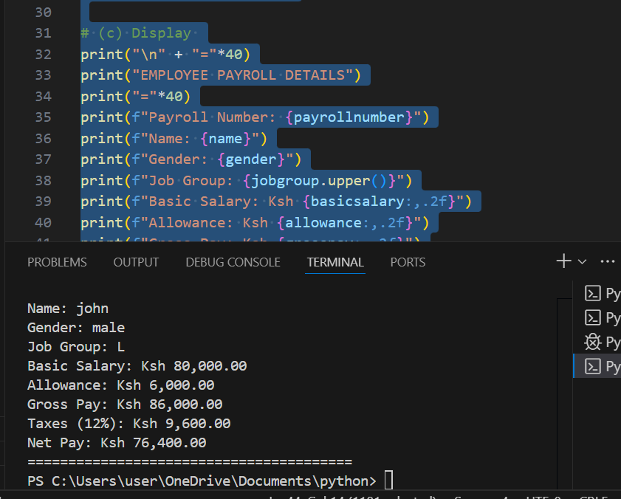
TASK2:
#user input
import math
a =float( input("Enter A: "))
b = float(input("Enter B: "))
h = float(input("Enter H: "))
area_of_trapezium=(1*(a+b)*h)/2
r=float(input("Enter Radius:"))
area_of_circle=math.pi * r**2
area_of_shaded_region=area_of_trapezium-area_of_circle
#output
print("area_of_trapezium:",area_of_trapezium)
print("area_of_circle:",area_of_circle)
print("area_of_shaded_region:",area_of_shaded_region)
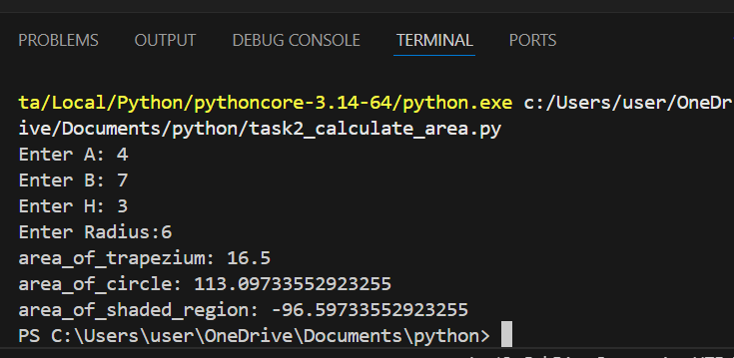
TASK3:
name=input("Enter Name:")
mark1=int(input("Enter 1st mark :"))
mark2=int(input("Enter 2nd mark :"))
mark3=int(input("Enter 3rd mark :"))
average=(mark1+mark2+mark3)/3
print("-"*50)
if average >= 80 and average <= 100:
grade='A'
comment='Excellent'
elif average >=70:
grade='B'
comment='very Good'
elif average >=60:
grade='C'
comment='Good'
elif average >=50:
grade='D'
comment='improve'
else:
grade='F'
comment='Fail'
#output
print("="*50)
print("Your Name is:",name)
print(f"mark1:{mark1}")
print(f"mark2:{mark2}")
print(f"mark3:{mark3}")
print(f"mark1:{mark1}")
print(f"Average:{average}")
print(f"Your Grade is:{grade}")
print(f"comment:{comment}")
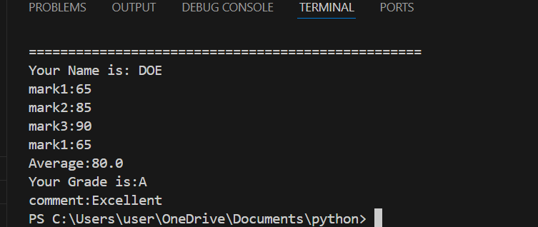
TASK4:
#TASK 4.
customername =str( input("Enter customer name: "))
age =int( input("Enter age: "))
monthlyincome = int(input("Enter monthly income: "))
creditscore =int( input("Enter credit score: "))
if monthlyincome >= 30000 and creditscore >= 700:
print("Approved")
print("He or she has met the requirement")
else:
print("Rejected")
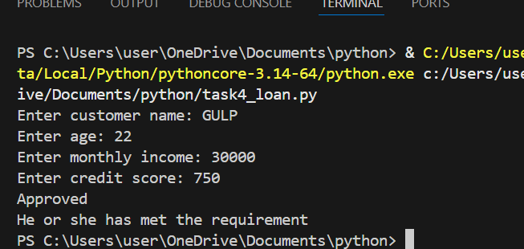
TASK5:
#temperature advisor
temperature=float(input("Enter temperature: "))
if temperature < 15:
print("It's cold- wear a jacket. ")
elif temperature >= 15 and temperature <=25:
print("The weather is pleasant- enjoy your day. ")
elif temperature > 25:
print("It's hot- stay hydrated. ")
else:
print("Please enter a valid number for temperature.")

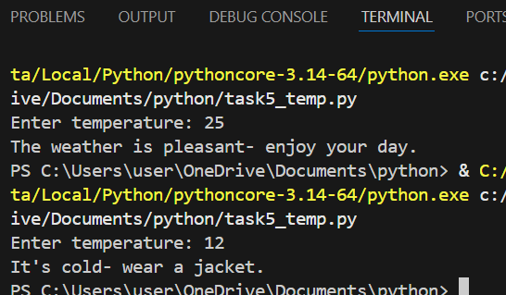
TASK6:
import math
a= float(input("Enter a:"))
b= float(input("Enter b:"))
c= float(input("Enter c:"))
equation= (b**2) - (4*a*c)
if equation > 0:
root1= (-b + math.sqrt(equation))/(2*a)
root2= (-b - math.sqrt(equation))/(2*a)
print(f"Roots are real and distinct:{root1} and {root2}")
elif equation == 0:
root =-b/(2*a)
print(f"roots are real and equal {root}")
else:
root=-b/(2*a)
root3=math.sqrt(-equation)/(2*a)
print(f"roots are complex: {root}+ {root3} and {root} - {root3} ")

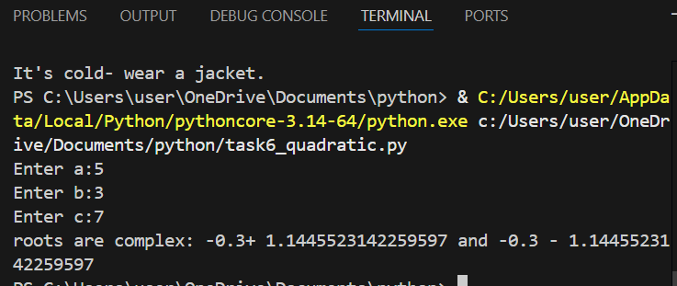
TASK7:
#input expenses
food= int(input("Enter food🍛 expenses: "))
transport=int( input("Enter transport🚕 expenses: "))
utilities=int( input("Enter utilities expenses: "))

total= food+transport+utilities
percentage_of_food=(food/total)*100
percentage_of_transport=(transport/total)*100
percentage_of_utilities=(utilities/total)*100

print(f"Food: {percentage_of_food:.1f}%")
print(f"Transport: {percentage_of_transport:.1f}%")
print(f"Utilities: {percentage_of_utilities:.1f}%")

if food > 50:
print("You are overspending on food.")
else:
print("Minimize the expenses.")
if utilities < 20:
print("utilities spending is minimal.")
else:
print("Utilities spending is significant.")
# Display neat table
print("\n" + "="*50)
print(f"{'EXPENSE BREAKDOWN':^50}")
print("="*50)
print(f"{'Category':<15} {'Amount ($)':<15} {'Percentage (%)':<15}")
print("-"*50)
print(f"{'Food':<15} {food:<15.2f} {percentage_of_food:<15.1f}")
print(f"{'Transport':<15} {transport:<15.2f} {percentage_of_transport:<15.1f}")
print(f"{'Utilities':<15} {utilities:<15.2f} {percentage_of_utilities:<15.1f}")
print("-"*50)
print(f"{'TOTAL':<15} {total:<15.2f} {100.0:<15.1f}")
print("="*50)
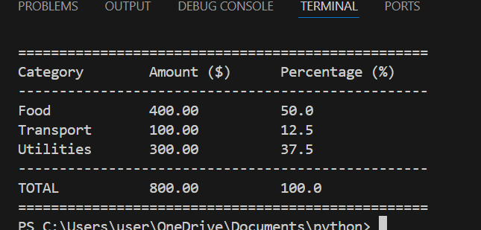
TASK8:
vehicle_name=(input("Enter vehicle name: "))
speed= int(input("Enter speed(km/h): "))
if speed <=80 :
print(" No fine")
elif speed >= 81 and speed <=100:
print(" fine = 3000")
elif speed >= 101 and speed <120:
print(" fine = 7000")
else:
print(" fine = 15000")
#output
print(f"Vehicle: ",vehicle_name)
print(f"Speed: {speed} km/h")

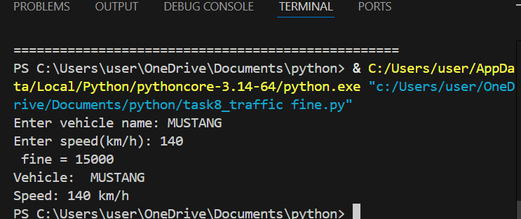
TASK9:
# Prompt for student details
print("🌟 Welcome to the Student Meal Card System! 🌟")
print("-" * 50)
student_name = input("Enter student name: ")
adm_No = int(input("Enter admission number: "))
meal_type = input("Enter meal type (Breakfast, Lunch, Supper): ").capitalize()
amountpaid = {"Breakfast": 100, "Lunch": 200, "Supper": 250}
mealcard = 1000

if meal_type not in amountpaid:
print("Invalid meal type. Please enter Breakfast, Lunch, or Supper.")
else:
cost = amountpaid[meal_type]
advice = "Maintain weekly top-up schedule"
remaining_balance = mealcard - cost

# Balance status
if remaining_balance < 150:
print("Low balance.")
else:
print("Sufficient amount.")

print("="*50)
# Output
print(f"Student Name: {student_name}")
print(f"Admission Number: {adm_No}")
print(f"Meal Type: {meal_type}")
print(f"Cost: {cost} KES")
print(f"Remaining Balance: {remaining_balance} KES")
print(f"Advice: {advice}")
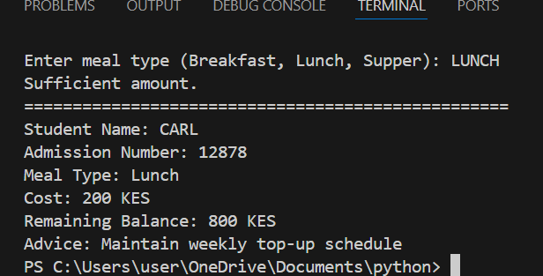
TASK10:
# Prompt student details
print("🎓 Welcome to the Career Guidance System! 🎓")
print("-"*40)
student_name = input("Enter student name: ")
subject = input("Enter subject (Math, Science, Business, Art, Home Science): ").strip().title()

if subject == 'Math':
career = "Data Analyst / Engineer"
elif subject == 'Science':
career = "Lab Technician / Researcher"
elif subject == 'Art':
career = "Designer / Animator"
elif subject == 'Business':
career = "Marketer / Accountant"
elif subject == 'Home Science':
career = "Catering & Accommodation"
else:
career = "Invalid subject. Please choose a valid option."

# Output
print("="*40)
print(f"Student Name : {student_name}")
print(f"Subject : {subject}")
print(f"Career Path : {career}")

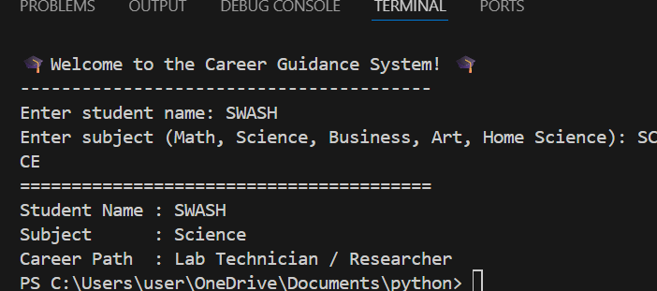
Admission No | Student Name | Signature
126719 | Caleb Kihika
125843 | Christine Gathoni
124806 | Evelyne Wanjiku

